2016 Free IC Fabrication mini@sic Program
For Brazilian universities
Jacobus W. Swart
Imec Brazil, Campinas, SP
jacobus.swart@imec.be

Considering:
- Brazil has several incentive programs for the stimulation of ASIC design and has set up several design houses
- Design houses need experienced IC designers
- Through the IC-Brazil Program several hundred designers have been trained and employed by the design houses
- Before entering the IC-Brazil Program and/or job market it would be beneficial if students at Undergraduate, Master and PhD level could have the chance to design small ICs and have them fabricated and tested

Imec Brazil would like to contribute to the growth of the IC ecosystem in Brazil by offering some free IC fabrication to Brazilian universities on Europractice mini@sic runs (www.europractice-ic.com).

In 2016 Imec Brazil offers 5 free seats on mini@asic (see concept at figure 1) MPW runs under next conditions and following successful experience in 2013 and 2014, when also 5 designs were supported (from FEI, PUC-RS, UFSC, UnB, UNICAMP and USP):
- Technology TSMC 0.18u MS/RF
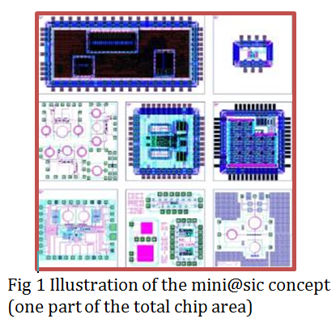
- On scheduled mini@sic runs: March and September 2016
- Maximum design area of a seat: 1660 x 1660 microns
- Delivery: free samples (dies), maximum 40
- Packaging: free up to 500 euro

Who can apply?
- Professors at Brazilian universities
- For non-funded Master or PhD student designs
- More application can be submitted, but maximum 1 design per university can be approved for free fabrication

How to apply?
- There are two deadlines for proposal submissions: 1 December 2015 and 1 May 2016, for tape out in March and September 2016 respectively (more details at www.europractice-ic.com).
- Submit appended application form to jacobus.swart@imec.be
- Imec will inform about the selection within 2 weeks after the submission deadlines

Design Selection Committee:
- Hamilton Duarte Klimach, UFRGS – indicated by SBMicro
- Hugo Puertas de Araújo, LSITec– indicated by IC-Brazil
- Jacobus Swart – imec Brazil

2016 Free IC Fabrication mini@sic Program
For Brazilian universities
Application Form

University Name and Faculty:

Name of advisor:

Name of student(s):

Study program of the student(s): (____) PhD, (___) Master, (___) Undergraduate

Commitment: (___) the authors are committed to mention “imec fabrication support” at related publications.

Description of the IC (type, application, novelty, approximate transistor count, main characteristics, etc)

