**IMEC Free Mini@sic Fabrication on TSMC 0.18 um Technology**

Title: Design of a Passive RFID Tag for 13,56MHz

Adviser Professors:

* Wellington Avelino do Amaral
* Gilmar Silva Beserra
* Sandro Augusto P. Haddad
* José Edil Guimarães de Medeiros

Students involved (names and aimed degrees)

* Marlon Carvalho Portugal Filho
* José Alisson de Albuquerque Pinto
* Roberta Rosa do Nascimento Hora Guimarães
* José Armando Rodrigues de Sousa Neto
* Henrique Malloni de Faria

University Name: Brasília University (UNB)

Faculty Name: UNB-Gama Faculty (FGA) and Department of Electrical Engineering (ENE)

Type of Circuit Design: ( ) Digital; (x) mixed signal; ( ) analog; ( ) RF

Date of the circuit tape-out of the run: 2014/04/02

Date of receiving the chips at your institution:

Date of the report and/or of later up-date: 2016/02/22

Short Description of the circuit: (function, proposed innovation, number of transistors, passive components, screen shot of the chip layout, etc)

Bandgap Voltage Reference: The circuit uses a traditional architecture and it is composed by an operational amplifier, an output buffer, bipolar transistors and a resistive voltage divider.

ASK Demodulator: The designed ASK demodulator uses an envelope detector, an average filter and a hysteresis comparator to provide binary values in its output.

CMOS Voltage Reference: CMOS voltage reference based on threshold voltage summation. Original circuit architecture that uses a threshold voltage extractor, trimmer structures and an operational amplifier. The circuit doesn't use bipolar transistors. Figure 1 shows the most important structure of this voltage reference; the Vth Extractor. It is responsible to generate a bias current proportional to the Vth voltage.

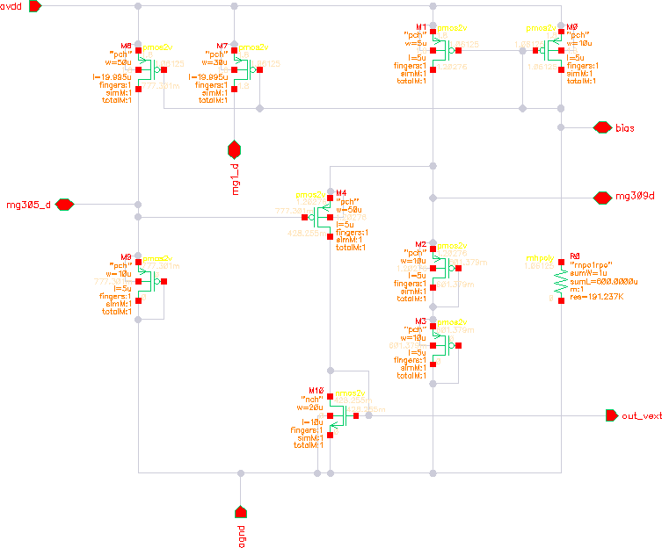

**Figure 1 -** Schematic of the CMOS voltage reference (Vth extractor)

Main results and representative performance curves

Figure 2 shows the simulation results of the bandgap voltage reference. As can be seen, a stable result was obtained in a range of -30°C to 130°C.

The ASK demodulator performance can be evaluated in figure 3. As can be seen, the circuit accomplished the expected functionality, presenting at its output a binary signal.

Figure 4 shows the simulation result of the CMOS voltage reference. The circuit presented a stable result in a range of -20°C to 120°C.

Figures 5 and 6 are the measurements results obtained from the bandgap voltage reference and ASK demodulator, respectively. The measurements shown a expressive difference from the simulations. It was concluded that this differences may have been generated by an incorrect use of the PADs structures.

|  |  |
| --- | --- |
| **Figure 2 -** simulation results of the bandgap voltage reference | **Figure 3 -** simulation results of the ASK demodulator |

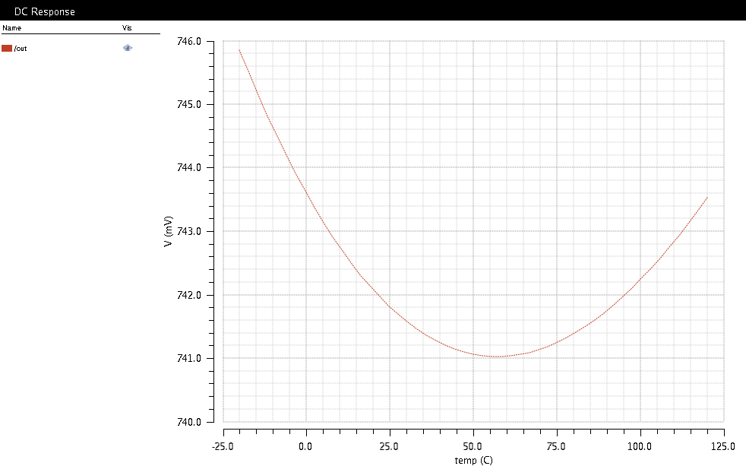

**Figure 4 -** Simulation result of the CMOS voltage reference

|  |  |
| --- | --- |
| **Figure 5 -** Bandgap voltage reference measurement results | **Figure 6 -** ASK demodulator measurement results |

Main challenges and difficulties encountered during design, submission, import process and measurements of the circuit.

The main difficulty was to understand the PADs structures. The realization of a LVS verification of the complete chip was hampered by this difficulty.

Resulting publications (submitted, accepted or published) and degrees earned by students

* Roberta Rosa do Nascimento Hora Guimaraes, "High level modeling of a heterogeneous system using frameworks based in MoC", end-of-graduation-course paper, 2014.
* Marlon Carvalho Portugal Filho, "Verilog-AMS modeling of a passive RFID tag and electrical design of a ASK demodulator", end-of-graduation-course paper, 2014.
* Henrique Malloni de Faria, "Design of a baseband processor for a passive RFID tag", end-of-graduation-course paper, 2015.
* José Armando Rodrigues de Sousa Neto, "Test, design and functional verification of a RFID tag for 13,56MHz", end-of-graduation-course paper, 2015.