IMEC Free Mini@sic Fabrication on TSMC 0.18 um Technology

Title: Digital read-out circuit (ROIC) for mid-infrared photodetectors

Adviser Professor(s): Alain André Quivy
Students involved (names and aimed degrees): Marcel Santos Claro (Ph.D. Candidate)

Institution: Instituto de Física da Universidade de São Paulo – IFUSP

Type of Circuit Design: ( ) Digital; (x) mixed signal; ( ) analog; ( ) RF

Date of the circuit tape-out of the run: 1st of October 2014
Date of receiving the chips at your institution: 10th of may 2015
Date of the report and/or of later up-date: 1st of February 2016

Short Description of the circuit: (function, proposed innovation, number of transistors, passive components, screen shot of the chip layout, etc)

The circuit was designed to work as a readout circuit for mid-infrared photodetectors produced in our laboratory (LNMS/IFUSP). Since the circuit is aimed to be used in FPAs (Focal Plane Arrays), it needs to be of the size of a FPA pixel (a few tens of microns), to operate at cryogenic temperatures (77 K or lower) and to be able to sense electrical currents in the 10⁻¹² A range with a low noise and low input impedance. The circuit that was designed here is different from the commercial analog circuits, since it allows the analog to digital conversion of the signal inside each individual pixel in order to circumvent the capacitor-saturation problems related to the usual integration times. Additionally, it has dynamical sensitivity, better noise immunity, and requires a much simpler and cheaper external electronics to control the FPA. Beyond these innovative features, we also included in the die a CTIA (Capacitive Trans-Impedance Amplifier) compatible with a 30um-wide pixel and some extra sub-circuits in order to investigate their behavior at cryogenic temperatures.

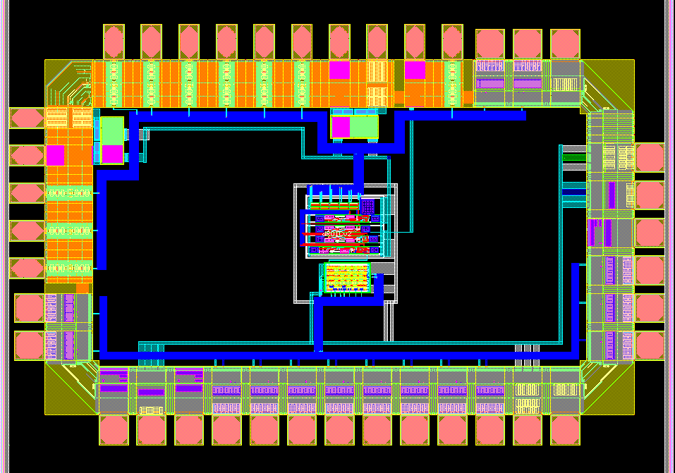
Figure 1: Chip layout. 39 Pads.

Main results and representative performance data or curves, picture of the IC, does circuit function as expected, etc

An encapsulated chip was mounted in an optical cryostat and connected to a standard photovoltaic QWIP (PV-QWIP) fabricated in our lab and absorbing at wavelengths around 10 µm. The sub-circuits, the digital ROIC and CTIA were tested at ambient and cryogenic temperatures. All of them performed as expected down to the lowest temperatures available in that cryostat (77 K). The chip is now being installed in another cryostat, equipped with a closed He circuit, in order to investigate the minimum operation temperature of the chip.
The voltage reference, a critical sub-circuit, was tested separately on a nude die installed in a cryogenic probe station, from 15 K to 300 K, and deviated more significantly from the simulated behavior. However, it is still functional and stable in the entire temperature range. This is the only part of the circuit that should be modified in a second version of the chip.
This is the first time that a mid-infrared photodetector built in Brazil and a readout-circuit designed in the same group can operate together. Such an achievement is only possible in a few countries over the world.

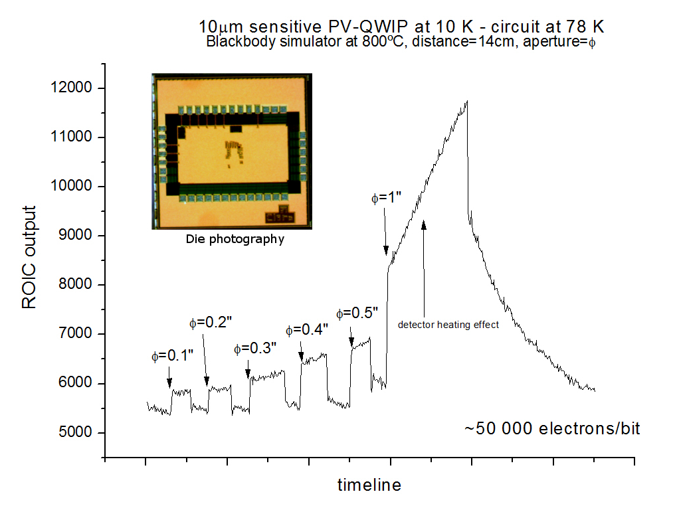
Figure 2: Output signal of the readout-circuit as a function of the elapsed time during the exposition of a PV-QWIP to the infrared radiation of a blackbody (set at 800 °C) having different circular apertures φ. The PV-QWIP was kept at 10 K in a cryostat and the ROIC was kept at 77 K in another cryostat, close to the PV-QWIP.

Main challenges and difficulties encountered during design, submission, import process and measurements of the circuit.

The design of the circuits for cryogenic temperatures was the main difficulty, since the physical models provided by the TSMC were limited to -55°C (218K). Therefore, some unverified extrapolations were made in order to predict the characteristics and performance of the circuit at lower temperatures. During the layout submission, many e-mail contacts were necessary with IMEC, since we did not have access to the layout of the TSMC pads and digital library, and the final design verification had to be performed several times by the IMEC staff.

Resulting publications (submitted, accepted or published) and degrees earned by students.

The results will be presented at the next SBMicro conference (August 2016)

