Free IC Fabrication mini@sic Program
For Brazilian universities
Jacobus W. Swart
Imec Brazil, Campinas, SP
jacobus.swart@imec.be
Considering:
- Brazil has several incentive programs for the stimulation of ASIC design and has set up several design houses
- Design houses need experienced IC designers
- Through the IC-Brazil Program several hundred designers have been trained and employed by the design houses
- Before entering the IC-Brazil Program and/or job market it would be beneficial if students at Undergraduate, Master and PhD level could have the chance to design small ICs and have them fabricated and tested
Imec Brazil would like to contribute to the growth of the IC ecosystem in Brazil by offering some free IC fabrication to Brazilian universities on Europractice mini@sic runs (www.europractice-ic.com).

Imec Brazil offers 5 free seats on mini@asic (see concept at figure 1) MPW runs each year under next conditions and following successful experience since 2013:
- Technology TSMC 0.18u MS/RF
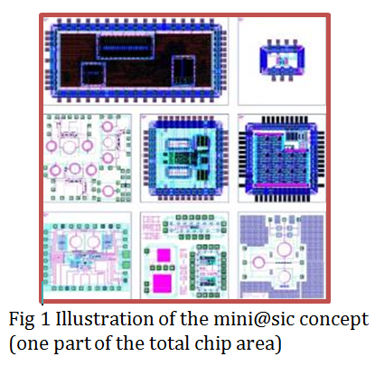
- Scheduled mini@sic runs: Twice a year, see dates at web site
- Maximum design area of a seat: 1660 x 1660 microns
- Delivery: free samples (dies), maximum 40
- Packaging: free up to 500 euro
Who can apply?
- Professors at Brazilian universities
- For non-funded Master or PhD student designs
- More application can be submitted, but maximum 1 design per university can be approved for free fabrication
How to apply?
- There is one deadline for proposal submission: 1 December of preceding year, for tape out in first and second semester of the year (more details at www.europractice-ic.com).
- Submit application form to jacobus.swart@imec.be
- Imec will inform about the selection within 2 weeks after the submission deadlines
Design Selection Committee:
- Name indicated by SBMicro
- Name indicated by CECCI/SBC
- Name indicated by IC-Brazil
- Jacobus Swart – imec Brazil
Reports:
- Short reports are requested after characterization. Previous designs that have been supported can be seen at http://www.europractice-ic.com/IMEC_Brazil_free_IC_fabrication.php

